Architecture Documentation
Intelligent Video Event Detection and Alerting Platform

1. Overview
This document describes the end-to-end architecture of the Intelligent Video Event Detection and Alerting Platform. The system ingests video from a file, webcam, or RTSP stream, detects and tracks people, applies configurable spatial and temporal analytics, evaluates a rule engine against that analytics, and produces debounced, evidence-backed events that are stored, alerted on, and displayed through a desktop dashboard.

2. Architecture Diagram
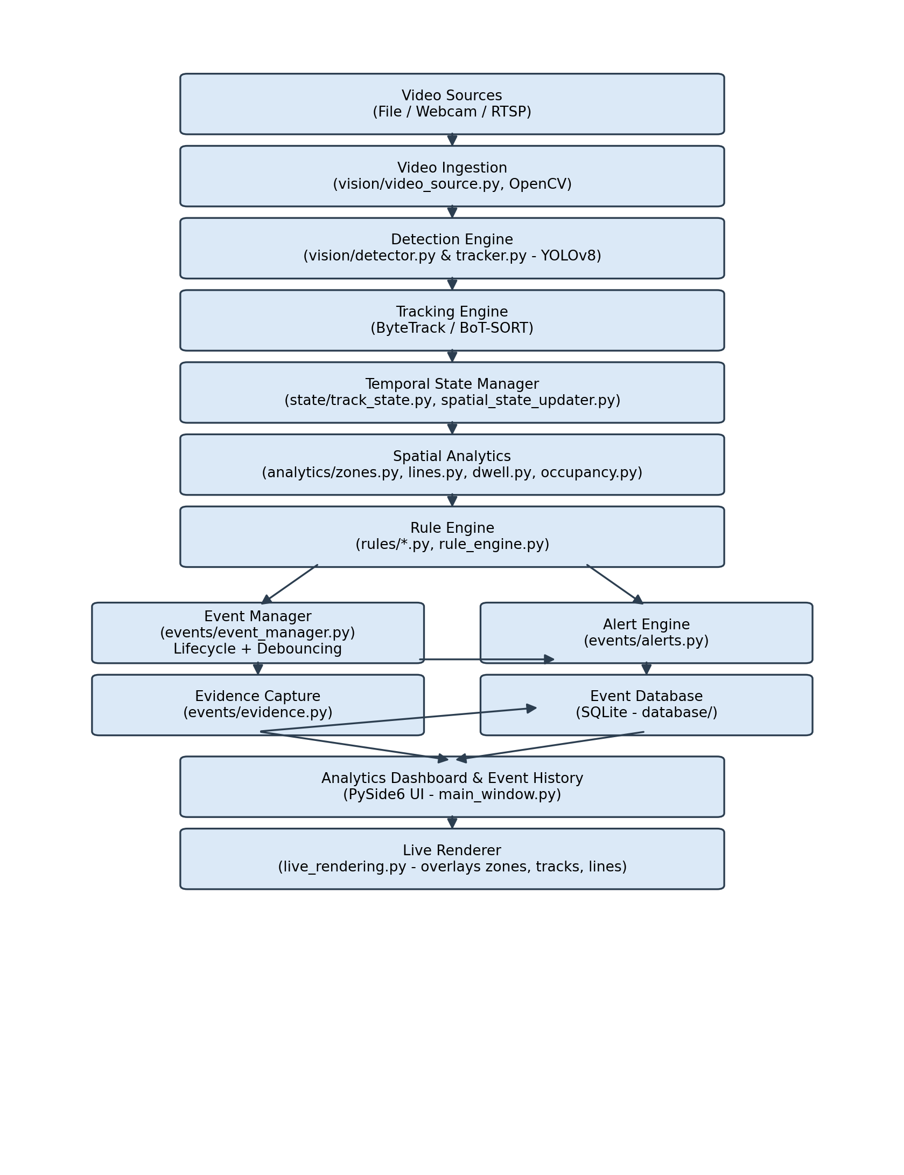

3. Component Descriptions

3.1 Video Sources & Ingestion
The application accepts three input types: an uploaded video file, a live webcam feed, or an RTSP network stream. All three are handled uniformly through OpenCV's VideoCapture, which transparently supports file paths, integer camera indices, and rtsp:// URLs using the same underlying decoder. This means the rest of the pipeline never needs to know which input type is active.

3.2 Detection Engine
A pretrained YOLOv8s model (vision/detector.py) performs person detection, filtered to COCO class 0. Detection is deliberately decoupled from tracking and business logic: the detector's only job is to return bounding boxes, confidence scores, and class labels for a single frame. Confidence threshold, selected classes, and model path are all externally configurable via .env / config.py.

3.3 Tracking Engine
vision/tracker.py wraps Ultralytics' built-in ByteTrack (default) or BoT-SORT tracker via model.track(), assigning persistent track IDs across frames. Tracking and detection are tightly coupled at the library level for this component, since ByteTrack requires the model's own internal detection pass; a separate detection-only path (detector.py) is retained for standalone testing and reuse.

3.4 Temporal State Manager
state/track_state.py maintains the authoritative per-track record: track ID, class, bounding box, confidence, position, first-seen/last-seen timestamps, current/previous zone, zone entry time, and a bounded trajectory (deque, capped length) of recent positions. state/spatial_state_updater.py coordinates between this state and the zone/dwell analytics, detecting zone transitions and updating dwell bookkeeping. All time-sensitive fields are driven by a single current_time value supplied by the caller each frame - either frame_count / fps for recorded video, or wall-clock time for live streams - ensuring dwell and staleness calculations remain accurate regardless of processing speed.

3.5 Spatial & Temporal Analytics
analytics/zones.py performs point-in-polygon membership testing (OpenCV's pointPolygonTest) against user-defined zone polygons. analytics/lines.py determines which side of a user-defined line a point falls on (via a cross-product sign test) to detect line crossings and direction violations. analytics/dwell.py computes live and historical dwell durations per zone. analytics/occupancy.py computes live headcounts per zone plus running max/average statistics. Each module is a pure calculation layer with no knowledge of rules, events, or the UI.

3.6 Rule Engine
rules/rule_engine.py loads rule definitions from user_settings/rules.json and evaluates each enabled rule's check() method every frame against a shared context dictionary. Four rule types are implemented (rules/intrusion.py, loitering.py, direction.py, occupancy_rule.py), each inheriting from a common BaseRule. This design allows new rule types to be added without modifying the main processing loop, and allows users to enable, disable, or retune existing rules through the Rules tab without code changes.

3.7 Event Manager
events/event_manager.py owns the event lifecycle (Detected -> Active -> Resolved) and implements debouncing: a rule that remains true across many consecutive frames updates a single Active event rather than creating a new one each frame. An event is only marked Resolved after its underlying condition has been false for a configurable grace period, which absorbs brief tracking flicker without generating spurious duplicate events.

3.8 Evidence Capture & Alert Engine
events/evidence.py captures a full annotated frame (with the relevant zone outline and the triggering track's bounding box drawn on it) plus a cropped close-up image, exactly once per new event, timestamped for chronological review. events/alerts.py formats new events into in-application alerts and a console-based secondary log channel.

3.9 Event Database
database/db.py defines the SQLite schema and connection handling; database/repository.py exposes save_event(), get_events() (with type/severity/zone/status filtering), and update_event_status() for manual acknowledgement/resolution from the Event History tab.

3.10 Analytics Dashboard, Event History & Live Rendering
The PySide6 desktop application (main.py, main_window.py) presents six tabs: Live View (video playback with live overlays via live_rendering.py), Zone Editor (interactive polygon/line drawing), Rules (enable/disable and threshold editing), Dashboard (live stats and matplotlib charts), Event History (filterable table with evidence viewing and manual resolution), and Settings (persisted configuration).

4. Design Rationale
The architecture deliberately separates concerns into distinct layers - vision, state, analytics, rules, events, and presentation - so that any single concern (e.g. swapping trackers, adding a new rule type, or changing the UI framework) can change without cascading edits through unrelated modules. This was validated in practice: the tracker was benchmarked against an alternative (BoT-SORT) without touching any downstream analytics or rule code, and new rule types were added purely as new subclasses of BaseRule.

